**HANOI UNIVERSITY OF SCIENCE AND TECHNOLOGY**

**School of Information and Communications Technology**

**Software Design Documentation**

AIMS Software

**Course: Software Design and Construction**

**Team**

**Lecturer**

**: 5**

**: Nguyen Thi Thu Trang**

**Member:**

|  |  |  |  |  |
| --- | --- | --- | --- | --- |
|  | **Full name** | **Student ID** | **Email** | **Class** |
| **1** | **Nguyễn Hữu Đức** | **20215353** | **Duc.NH215353@sis.hust.edu.vn** | **IT1** |
| **2** | **Nguyễn Mạnh Đức** | **20215350** | **Duc.NM215350@sis.hust.edu.vn** | **IT1** |
| **3** | **Nguyễn Văn Đức** | **20204530** | **Duc.NV204530@sis.hust.edu.vn** | **IT1** |
| **4** | **Nguyễn Trọng Đức** | **20215356** | **Duc.NT215356@sis.hust.edu.vn** | **IT1** |
| **5** | **Trần Tiến Đức** | **20204643** | **Duc.TT204643@sis.hust.edu.vn** | **IT1** |

Hanoi, 10/2024

**Table of Contents**

1. Introduction 3

1.1. Objective 3

1.2. Scope 3

1.3. Glossary 3

1.4. References 3

2. Overall Description 3

2.1. Survey 3

2.2. Overall requirements 4

2.3. Business process 4

3. Detailed Requirements 7

3.1. Use case “Place Order” 7

3.2. Use case “Place Rush Order” 9

3.3. Use case “Pay Order” 11

4. Supplementary specification 12

4.1. Functionality 12

4.2. Usability 12

4.3. Reliability 12

4.4. Performance 12

4.5. Supportability 13

# Introduction

# Objective

This SRS is a comprehensive blueprint for the development of an internet media store (AIMS). This document will serve as a guide for the development team, ensuring that the final product meets the specified requirements and aligns with the project's goals. It also provides information for testing team to create test cases and ensure that the developed system adheres to the specified requirements and for documentation team to create user manual and related documents.

# Scope

The product that the SRS refers to is AIMS Software (An Internet Media Store Software). AIMS is a desktop e-commerce software supporting online transactions of a media store. It helps the product managers completing their work in managing products of the store, also assists administrators controlling information of their users. The software at the same time is used by customers for selecting the products they want to purchase, placing and paying the orders.

# Glossary

|  |  |  |  |  |
| --- | --- | --- | --- | --- |
| **No** | **Term** | **Explanation** | **Example** | **Note** |
| 1 | product | The item that store sells in general | Customers can see detail of a product by clicking at the item. |  |
| 2 | price | The amount of money charged for a product | The price of the product may change depending on market demand. |  |
| 3 | value | The perceived worth of a product, determined by factors such as  quality, demand and customer satisfaction | The price of the product must always be between  30% and 150% of the product value. |  |
| 4 | order | A request to supply products in the store | To place a successful order, customers need to proceed with payment. |  |
| 5 | invoice | A statement listing products  provided and their prices, along with customer and order’s related  information | The software displays and temporarily save invoice information. |  |
| 6 | cart | A virtual collection that contains all the products selected by  customers | There is one cart per software session. |  |

# References

* AIMS – Problem Statement v2.0 – Nguyen Thi Thu Trang, HUST

# Overall Description

# Survey

There are 4 main actors:

* Product manager: Responsible for managing products and orders in the store
* Administrator: Responsible for managing users information
* Customer: The people who wants to buy goods from media store
* VNPay: The banking system responsilbles for customers’ payment of the orders

# Overall requirements

General use case diagram:

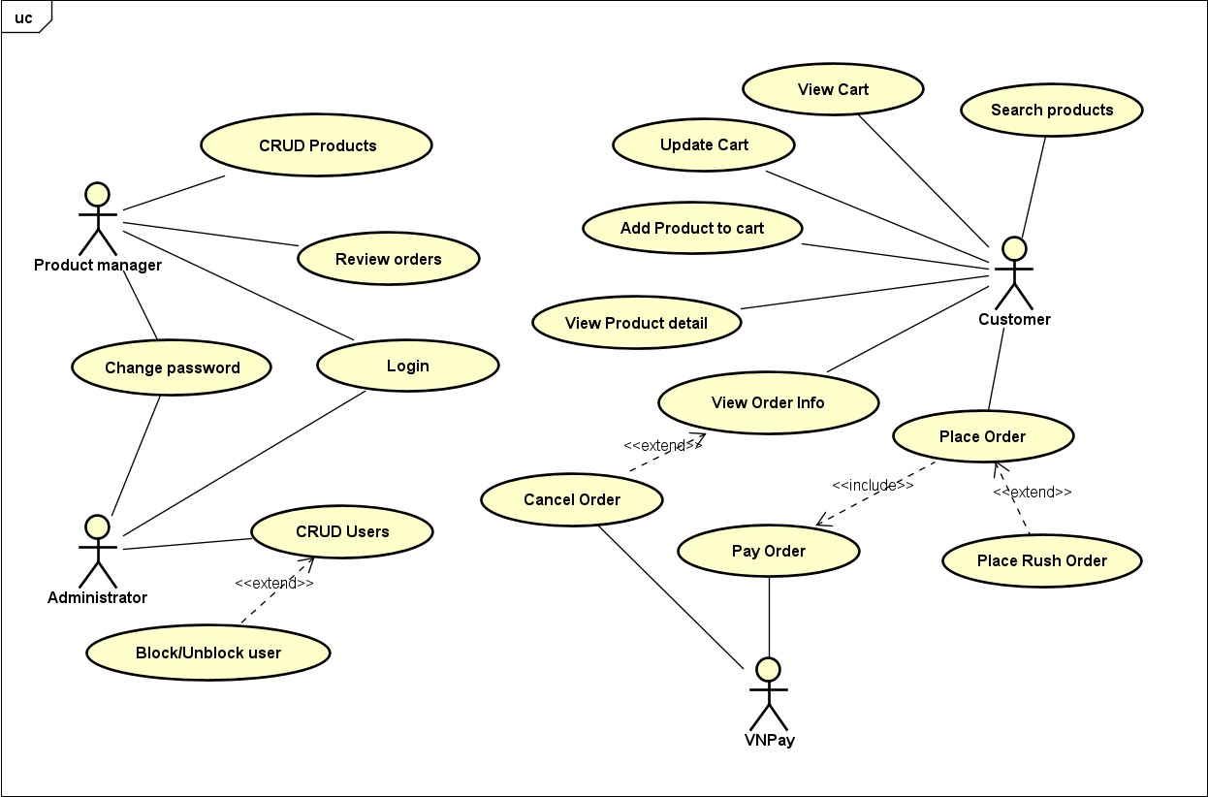

# Business process

Use case “Place Order”:

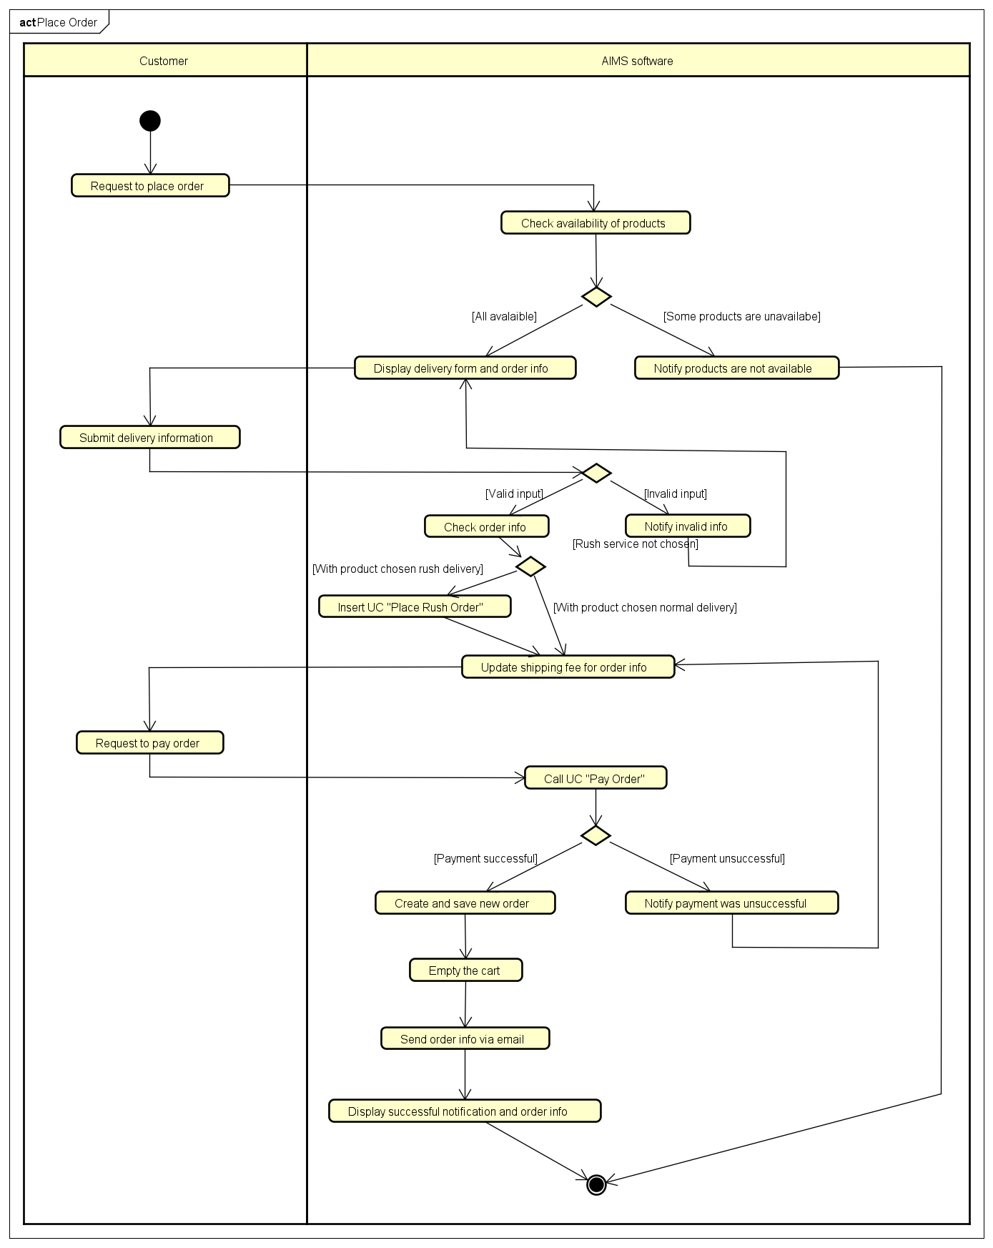

Use case “Place Rush Order”:

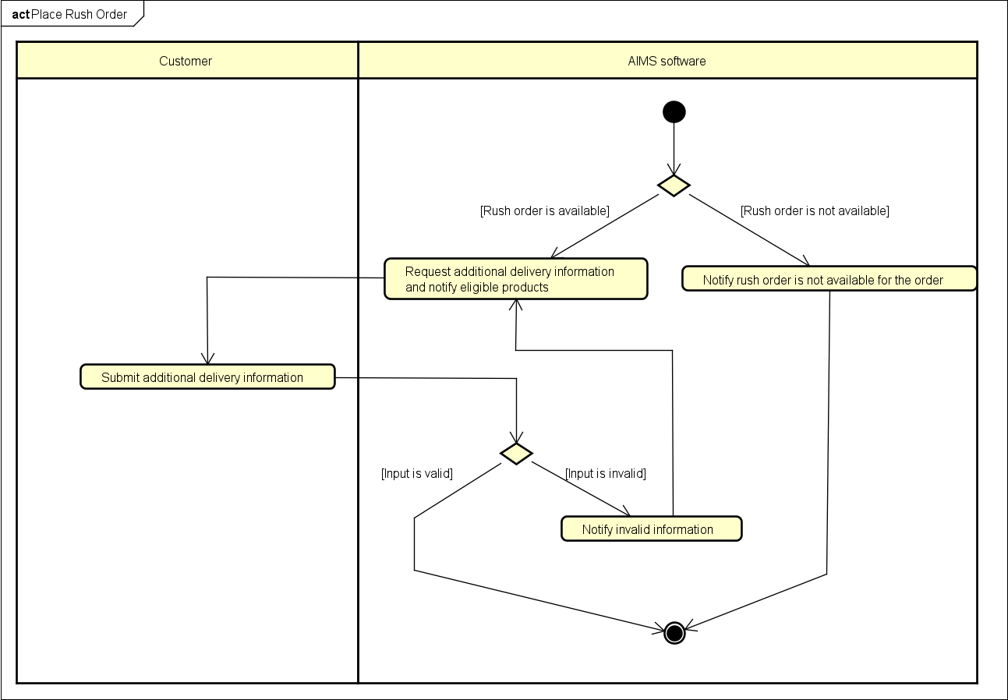

Use case “Pay Order”:

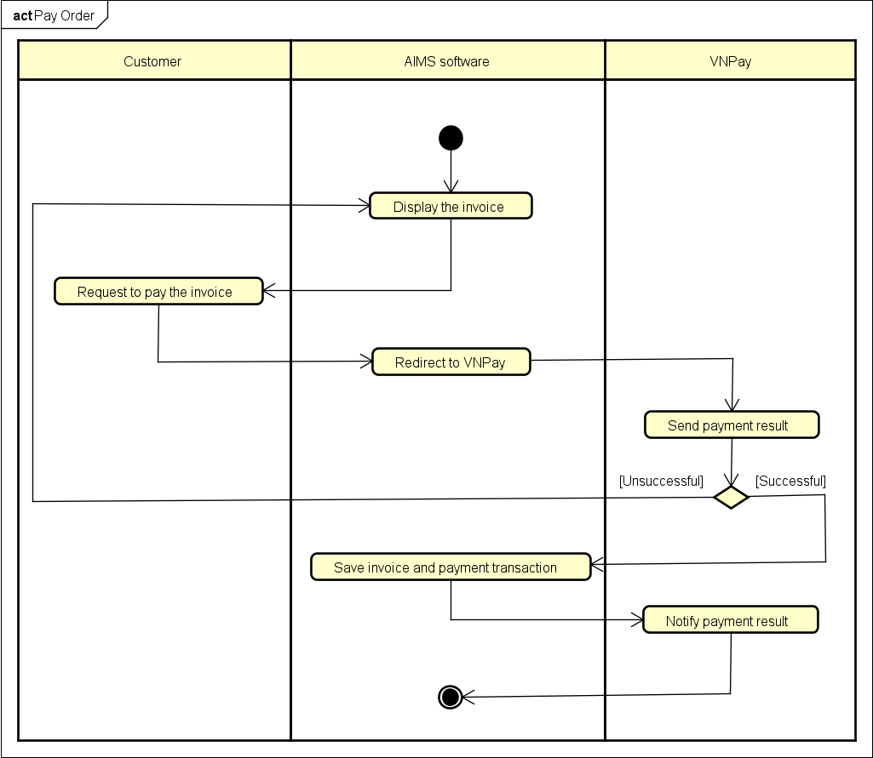

# Detailed Requirements

|  |  |  |  |  |
| --- | --- | --- | --- | --- |
|  |  |  |  |  |
|  |  |  |  |  |
|  |  |  |  |  |
|  |  |  |  |  |
|  |  |  |  |  |

# Use case “Place Order”

|  |  |  |  |  |  |  |  |
| --- | --- | --- | --- | --- | --- | --- | --- |
| **Use case “Place Order”**   1. **Use case code**   UC001   1. **Brief Description**   This use case describes the interaction between a customer and AIMS software when the customer wishes to place and purchase an order created by him/herself.   1. **Actors**    1. Customer 2. **Preconditions**   There is at least one item in the cart.   1. **Basic Flow of Events** 2. Customer requests to place order in the cart 3. AIMS software checks the availability of products in the cart 4. AIMS software displays the form of delivery information with order information 5. Customer enters and submits delivery information (see Table 1) 6. AIMS software calculates and updates order information with shipping fees (see Table 2) 7. The customer asks to pay order 8. AIMS software calls UC “Pay order” 9. AIMS software creates and saves a new order 10. AIMS software makes the cart empty 11. AIMS software sends email about the order notification and information 12. AIMS software displays the successful order notification, the order and the transaction information (see Table 3) 13. **Alternative flows**   No Location Condition Action Resume location  AIMS software notifies that   * 1. At Step 3 If the products are not the products in cart are not Use case ends available available and stay at the use   case “View cart”  If the delivery info is AIMS software notifies that   * 1. At Step 5 invalid the delivery info is invalid At Step 3   (blank or wrong format)  If the user chooses to AIMS software inserts use   * 1. At Step 5 place a rush order case At Step 6   “Place rush order”  If the order payment is AIMS software notifies that   * 1. At Step 8 not successful or goes the payment is unsuccessful. At Step 5   back from payment   1. **Input data**   Table 1: Input data of delivery information | | | | | | | |
|  | No | Data fields | Description | Mandatory | Valid  condition | Example |  |
| 1 | Receiver name |  | Yes |  | Nguyen Huu Duc |  |

|  |  |  |  |  |  |  |  |  |
| --- | --- | --- | --- | --- | --- | --- | --- | --- |
|  | 2 | Phone number |  | Yes | 10 digits | 0123456789 | |  |
| 3 | Province | Choose from a list | Yes |  | Hanoi | |  |
| 4 | Address |  | Yes |  | 1 Dai Co Viet street, Hai Ba Trung district | |  |
| 5 | Shipping  instructions |  | No |  | Call me 15 minutes before delivering! | |  |
| **8. Output data**  Table 2: Output data of order information and shipping fee  Table 3: Output data of general information of order and transaction info | | | | | | | | |
|  | No | Data field | Description | Display format | | | Example |  |
| 1 | Customer name |  |  | | | Nguyen Huu Duc |  |

|  |  |  |  |  |
| --- | --- | --- | --- | --- |
| No | Data field | Description | Display format | Example |
| 1 | Title | Title of a media product |  | DVD Phim Vượt ngục |
| 2 | Price | Price of the corresponding media product | * Comma for thousands separator * Positive integer * Right alignment | 123,000 |
| 3 | Quantity | Quantity of the corresponding media product | Positive integer Right alignment | 2 |
| 4 | Amount | Total money of the corresponding  media product | * Comma for thousands separator * Positive integer * Right alignment | 246,000 |
| 5 | Subtotal | Total amount of all products in the order | * Comma for thousands separator * Positive integer * Right alignment | 2,316,000 |
| 6 | Shipping fee | Calculated shipping fee for the order | * Comma for thousands separator * Positive integer * Right alignment | 30,000 |
| 7 | Total | The amount of money customer has to pay | * Comma for thousands separator * Positive integer * Right alignment | 2,346,000 |

|  |  |  |  |  |
| --- | --- | --- | --- | --- |
|  |  |  |  |  |
|  |  |  |  |  |
|  |  |  |  |  |
|  |  |  |  |  |
|  |  |  |  |  |
|  |  |  |  |  |
|  |  |  |  |  |
|  |  |  |  |  |

|  |  |  |  |  |  |  |
| --- | --- | --- | --- | --- | --- | --- |
|  | 2 | Phone number |  |  | 0123456789 |  |
| 3 | Province |  |  | Hanoi |  |
| 4 | Address |  |  | 1 Dai Co Viet street, Hai Ba Trung district |  |
| 5 | Total amount |  | * Right alignment * Vietnamese currency (VNĐ) * Vietnamese locale | 1,200,000 VNĐ |  |
| 6 | TransactionID | The ID of the  transaction stored in the database |  | VN010834018 |  |
| **9. Postconditions**  A new order is created, and its information is sent via email to the customer or nothing happens if payment is not successful. | | | | | | |

# Use case “Place Rush Order”

|  |  |  |  |  |  |  |
| --- | --- | --- | --- | --- | --- | --- |
| **Use case “Place Rush Order”**   1. **Use case code**   UC003   1. **Brief Description**   This use case describes the interaction between a customer and AIMS software when the customer wishes to place a rush order created by him/herself.   1. **Actors**    1. Customer 2. **Preconditions**   Customer selected Rush Order service.   1. **Basic Flow of Events** 2. AIMS software notifies the information about eligible products for the service (update Table 2) 3. AIMS software requests additional rush order delivery information (see Table 1) 4. Customer enters and submits required information 5. AIMS software checks and saves additional information   **6. Alternative flows** | | | | | | |
|  | No | Location | Condition | Action | Resume location |  |
| 1 | At Step 1 | If all of the products  are not eligible for rush order service or  delivery address  doesn’t support rush order service. | AIMS software notifies that rush order service is not  available for this order | Use case ends |  |

|  |  |  |  |  |  |  |  |  |  |
| --- | --- | --- | --- | --- | --- | --- | --- | --- | --- |
|  | 2 | At Step 4 | If the additional info is invalid | | AIMS software notifies that the additional info is invalid (blank or wrong format) | | | At Step 2 |  |
| 1. **Input data**   Table 1: Input data of additional information for rush order service   1. **Output data**   Table 2: Output data of order information and shipping fee with Rush Order service | | | | | | | | | |
|  | No | Data field | | Description | | Display format | Example | |  |
| 1 | Title | | Title of a media product | |  | DVD Phim Vượt ngục | |  |
| 2 | Price | | Price of the corresponding media product | | * Comma for thousands separator * Positive integer * Right alignment | 123,000 | |  |
| 3 | Quantity | | Quantity of the corresponding  media product | | * Positive integer * Right alignment | 2 | |  |
| 4 | Amount | | Total money of the corresponding  media product | | * Comma for thousands separator * Positive integer * Right alignment | 246,000 | |  |
| 5 | Rush delivery option | | Availability for rush delivery of the corresponding product | | Y/N | Y | |  |
| 5 | Subtotal | | Total amount of all products in the order | | * Comma for thousands separator * Positive integer * Right alignment | 2,316,000 | |  |
| 6 | Shipping fee | | Calculated shipping fee for the order | | * Comma for thousands separator * Positive integer * Right alignment | 110,000 | |  |

|  |  |  |  |  |  |
| --- | --- | --- | --- | --- | --- |
| No | Data fields | Description | Mandatory | Valid  condition | Example |
| 1 | Delivery time |  | Yes | DD/MM/YYYY hh:mm | 04/01/2025 16:30 |
| 2 | Rush delivery instructions |  | No |  | Be careful with the eggs! |

|  |  |  |  |  |  |  |
| --- | --- | --- | --- | --- | --- | --- |
|  | 7 | Total | The amount of money customer has to pay | * Comma for thousands separator * Positive integer * Right alignment | 2,426,000 |  |
| **9. Postconditions**  The status of products in the order are updated with Rush Order service. | | | | | | |

|  |  |  |  |  |
| --- | --- | --- | --- | --- |
|  |  |  |  |  |
|  |  |  |  |  |

# Use case “Pay Order”

|  |  |  |  |  |  |  |
| --- | --- | --- | --- | --- | --- | --- |
| **Use case “Pay Order”**   1. **Use case code**   UC002   1. **Brief Description**   This use case describes the interaction between a customer and VNPay as banking system towards AIMS software when the customer wishes to purchase the cost of an order created by him/herself.   1. **Actors**    1. Customer    2. VNPay 2. **Preconditions** 3. **Basic Flow of Events** 4. AIMS software displays the invoice (see Table 1) 5. Customer asks to pay the invoice 6. AIMS software redirects to VNPay 7. VNPay sends payment result to AIMS software 8. AIMS software saves invoice and payment transaction 9. AIMS software notifies the payment result to user 10. **Alternative flows**   No Location Condition Action Resume location  If the customer cancels AIMS software notifies that  1 At Step 5 the payment the invoice was not paid At Step 1 transaction successfully and displays the  invoice again   1. **Input data** 2. **Output data**   Table 1: Output data of invoice | | | | | | |
|  | No | Data field | Description | Display format | Example |  |
| 1 | Title | Title of a media product |  | DVD Phim Vượt ngục |  |
| 2 | Price | Price of the  corresponding media product | * Comma for thousands separator | 123,000 |  |

|  |  |  |  |  |  |  |
| --- | --- | --- | --- | --- | --- | --- |
|  |  |  |  | * Positive integer * Right   alignment |  |  |
| 3 | Quantity | Quantity of the corresponding media product | * Positive integer * Right   alignment | 2 |  |
| 4 | Amount | Total money of the corresponding media product | * Comma for thousands separator * Positive integer * Right   alignment | 246,000 |  |
| 5 | Subtotal  before VAT | Total price of products in the cart before VAT | 2,106,000 |  |
| 6 | Subtotal | Total price of products in the cart with VAT | 2,316,000 |  |
| 7 | Shipping fee | Calculated shipping fee for the order | 30,000 |  |
| 8 | Total | The amount of money customer has to pay | 2,346,000 |  |
| 9 | Currency |  |  | VNĐ |  |
| 10 | Name |  |  | Nguyen Huu Duc |  |
| 11 | Phone number |  |  | 0123456789 |  |
| 12 | Province |  |  | Hanoi |  |
| 13 | Address |  |  | 1 Dai Co Viet street, Hai Ba Trung district |  |
| 14 | Shipping  instructions |  |  | Call me 15 minutes before delivering! |  |
| **9. Postconditions**  Payment for order is completed, VNPay returns status of the purchase to AIMS software. | | | | | | |

# Supplementary specification

# Functionality

* The software ensures that each action can only be done by person with permission (for managing use cases).
* Sensitive data is encrypted.

# Usability

* The software allows new users to easily familiarize themselves.

# Reliability

* The software can resume normal operation within a maximum of 1 hour after an incident.

# Performance

* AIMS software can serve up to 1000 customers simultaneously without significantly reducing performance and can operate continouosly for 300 hours without failure.
* The maximum response time of the software is 2 seconds under normal conditions or 5 seconds during peak hours.

# Supportability

* Separated test environments will be prepared to carry out functional, integration and acceptance tests